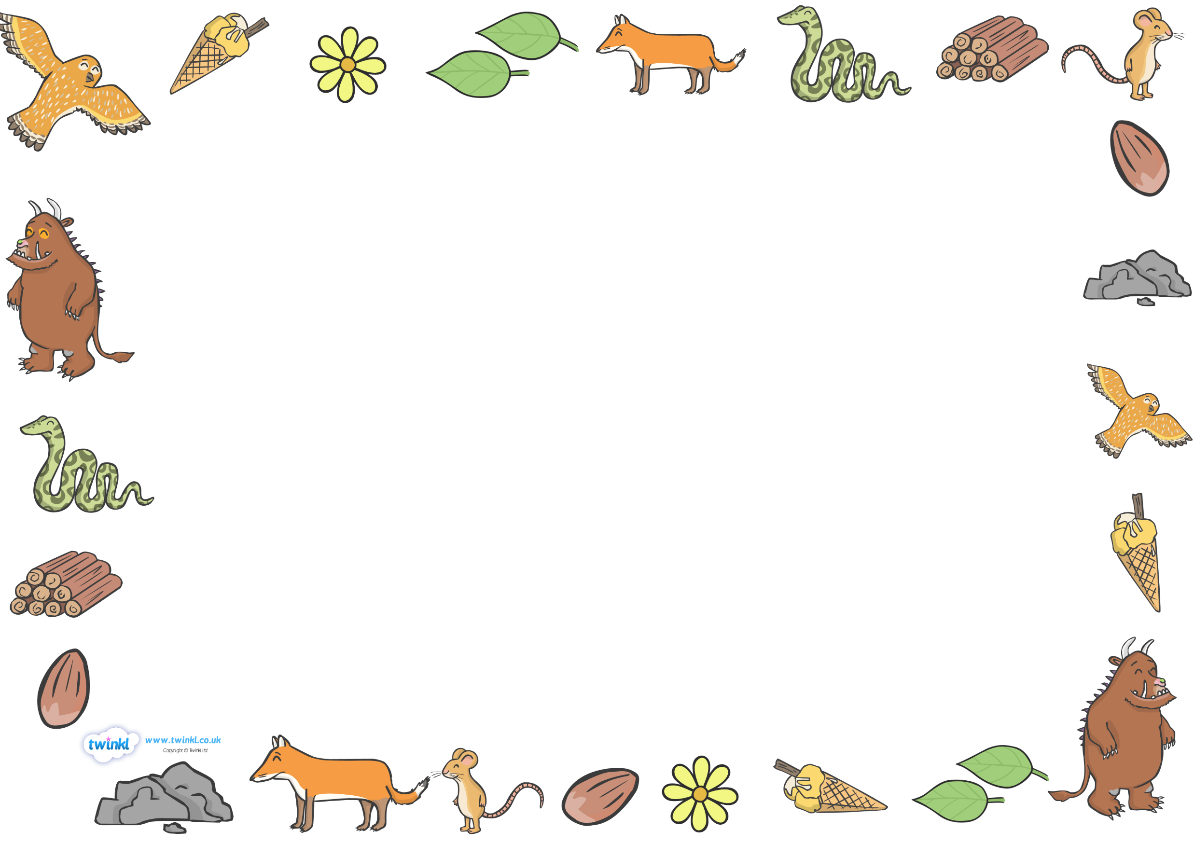

**The Gruffalo**

*by Julia Donaldson*

Cast list:

* Mouse
* Fox
* Owl
* Snake
* Gruffalo



Scene 1

*A mouse took a stroll through the deep dark wood*

Fox: *(slyly)* Where are you going to, little brown mouse? Come and have lunch in my underground house.

Mouse: *(happily)* It’s terribly kind of you, Fox, but no *(shakes his head)*. I’m going to have lunch with a gruffalo.

Fox: *(confused)* A gruffalo? What’s a gruffalo?

Mouse: *(shocked)* A gruffalo! Why, didn’t you know? He has terrible tusks *(makes pretend tusks with fingers)* and terrible claws *(makes hands look like claws* and terrible teeth in his terrible jaws *(points to his mouth)*.

Fox: Where are you meeting him?

Mouse: Here, by these rocks *(points)*, and his favourite food is roasted fox.

Fox: *(Frightened)* Roasted fox! *(raises his eyebrows)* I’m off! Goodbye, little mouse *(runs away)*.

Mouse: *(Laughing to himself)* Silly old fox! Doesn’t he know, there’s no such thing as a gruffalo?



Scene 2

*The mouse continued to walk through the deep, dark wood*

Owl: *(Wisely)* Where are you going to, little brown mouse? Come and have tea in my treetop house.

Mouse: *(Happily)* It’s frightfully nice of you, owl, but no *(Shakes his head)*. I’m going to have tea with a gruffalo.

Owl: *(Asking politely)* A gruffalo? What’s a gruffalo?

Mouse: A Gruffalo! Why, didn’t you know? He has knobbly knees *(points to his knees)*, and turned out toes *(points to his toes)* and a poisonous wart on the end of his nose *(puts his finger tip on the tip of his nose)*.

Owl: Where are you meeting him?

Mouse: Here by this stream and his favourite food is owl ice cream.

Owl: *(Frightened)* Owl ice cream? Toowhit toowhoo! Goodbye little mouse! *(Flies away quickly).*

Mouse: *(Laughing to himself)* Silly old owl! Doesn’t he know, there’s no such thing as a gruffalo?



Scene 3

*The mouse walked on through the deep dark wood.*

Snake: *(Hissing quietly)* Where are you going to, little brown mouse? Come for a feast in my log pile house.

Mouse: *(Happily)* It’s wonderfully good of you, Snake, but no *(Shakes his head)*. I’m having a feast with a gruffalo.

Snake: *(Asking politely)* A gruffalo? What’s a gruffalo?

Mouse: A gruffalo! Why, didn’t you know? His eyes are orange *(turns hands into glasses)*, his tongue is black *(sticks tongue out)* and he has purple prickles all over his back *(uses thumb of point to his back)*.

Snake: Where are you meeting him?

Mouse: Here, by this lake and his favourite food is scrambled snake.

Snake: *(Frightened)* Scrambled snake! It’s time I hid! Goodbye, little mouse. *(Slithers away rapidly)*

Mouse: *(Laughing quietly to himself)* Silly old Snake! Doesn’t he know, there’s no such thing as a gruffal… *(Stops laughing suddenly)*



Scene 4

*The mouse stops in his tracks at the sight before him*

Mouse: OH! Oh help! Oh no! It’s a gruffalo! *(Stops suddenly)*

Gruffalo: *(Growls deeply)* My favourite food, you’ll taste good on a slice of bread! *(Rubs his tummy hungrily)*

Mouse: Good? Don’t call me good! *(Hands on his hips)* I’m the scariest creature in this wood. Just walk behind me and soon you’ll see everyone is afraid of me. *(Points at the Gruffalo)*

Gruffalo: All right, you go ahead and I’ll follow after. *(Walks for a short distance)* I hear a hiss in the leaves ahead.

Mouse: *(Waves happily)* It’s Snake, why Snake, hello!

Snake: Oh crumbs, goodbye little mouse. *(Slithers away quickly)*

Mouse: You see? I told you so. (Smiling)

Gruffalo: Amazing! *(a short time later)* I hear a hoot in the trees ahead.

Mouse: *(waves happily)* It’s Owl. Why, Owl, hello!

Owl: Oh dear, goodbye little mouse. *(Flies away speedily)*

Mouse: You see? I told you so. *(Hands on hips and pointing at the Gruffalo).*

Gruffalo: Astounding! *(Walks for a few minutes more)* I can hear feet on the path ahead.

Mouse: *(Waves happily)* It’s Fox. Why, Fox, hello!

Fox: Oh help, goodbye little mouse. *(Scuttles away rapidly)*

Mouse: Well, Gruffalo, you see? *Everyone* is afraid of me! But now my tummy’s beginning to rumble *(pats tummy)* and my favourite food is – gruffalo crumble! *(loudly)*

Gruffalo: *(Surprised)* Gruffalo crumble! *(Flees whimpering)*