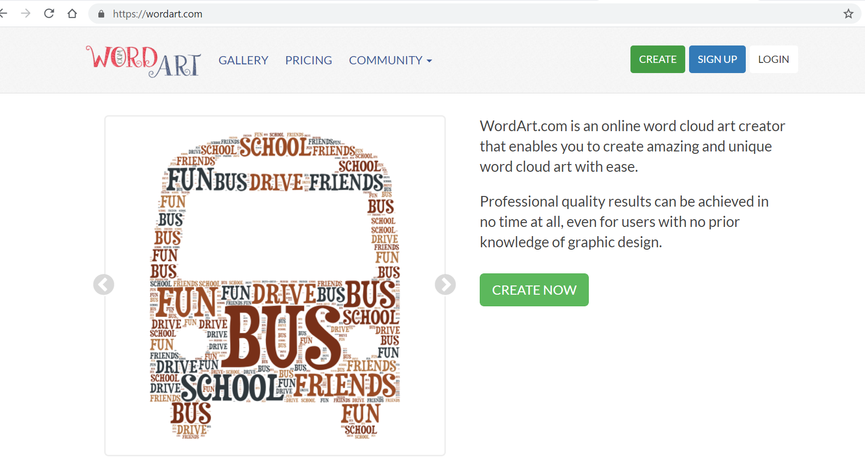

Select the create button to begin.

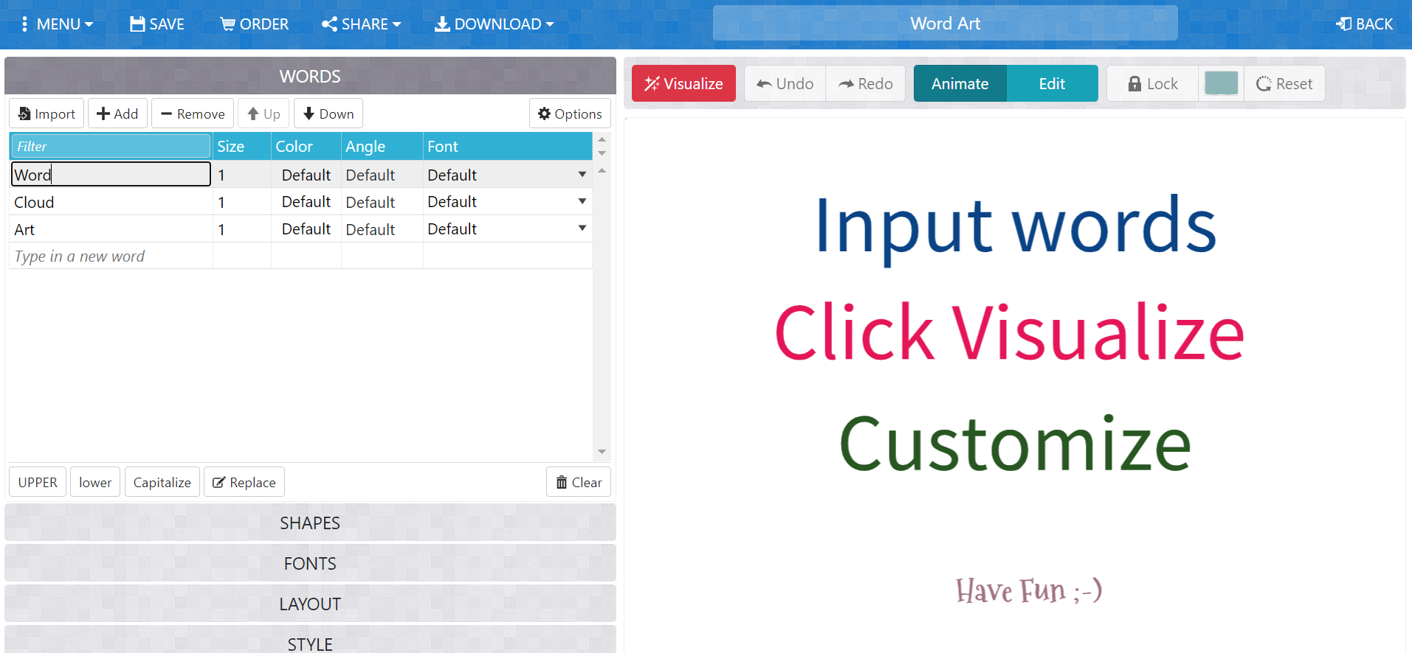

Select the words already there and remove them.

Then type in your own words and change the colour of the words.
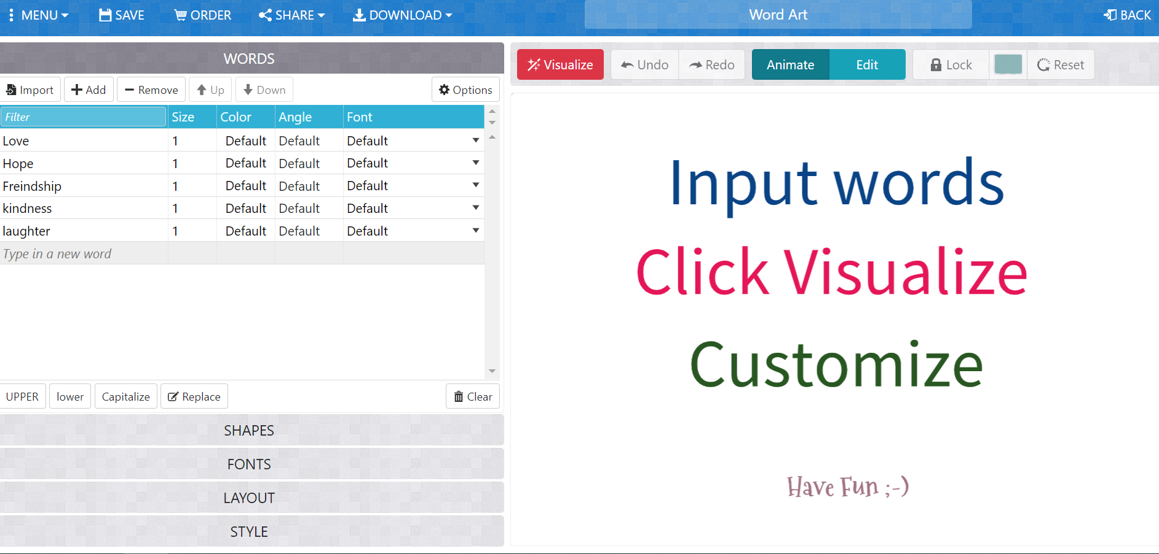

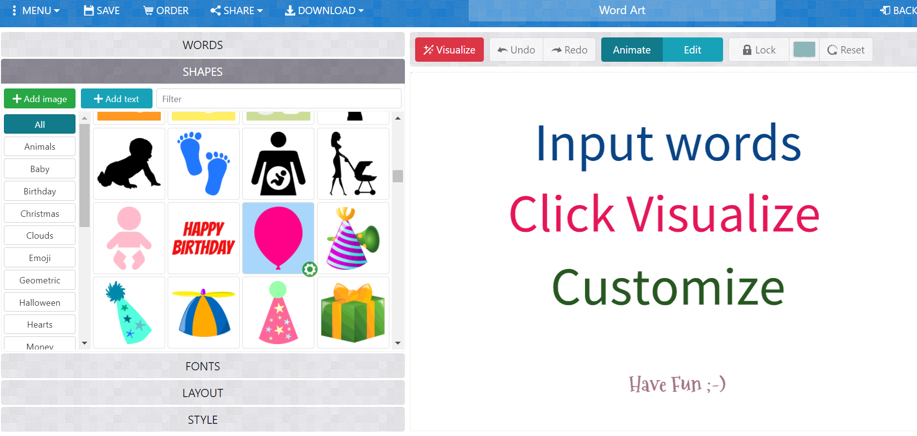

Then select shapes to choose a shape to insert your words into.
Then click visualize.

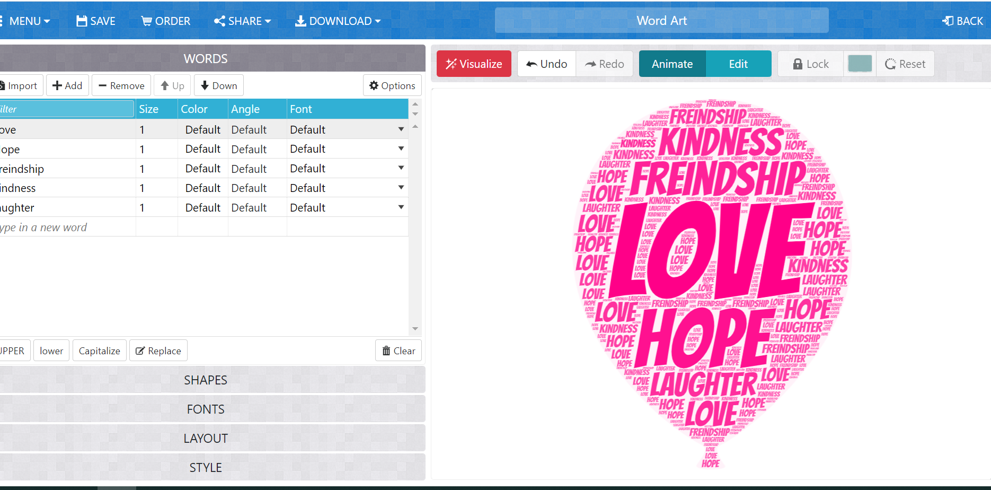
You will then be able to see your word art.
Lastly, you can edit the font, layout and style. Have a play around with these to find something that you like.

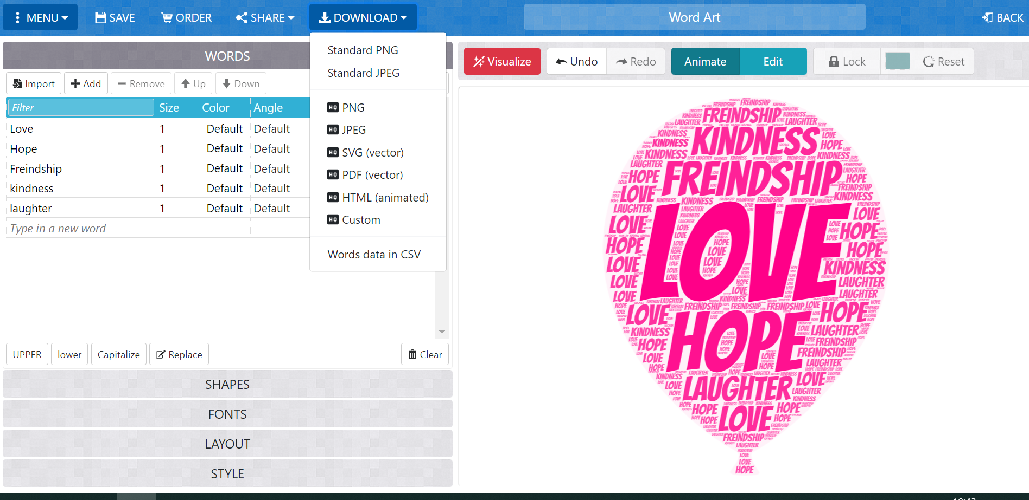
Once you are happy with your word art, you can download it as a standard JPEG.

