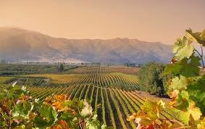
_____________________________________

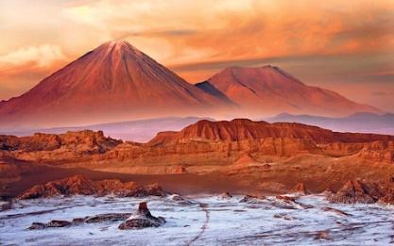
___________________________________

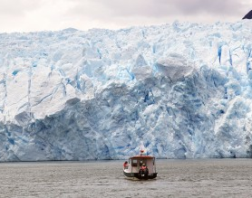
_____________________________________

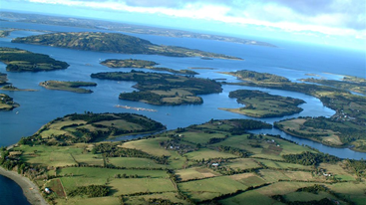
_____________________________________

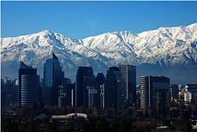
_____________________________________

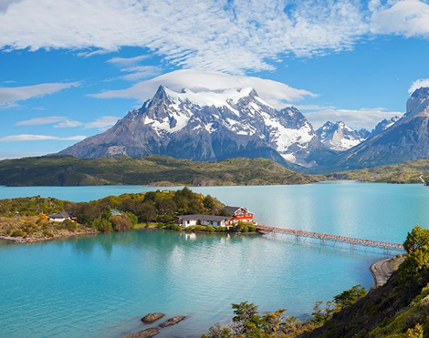
_____________________________________

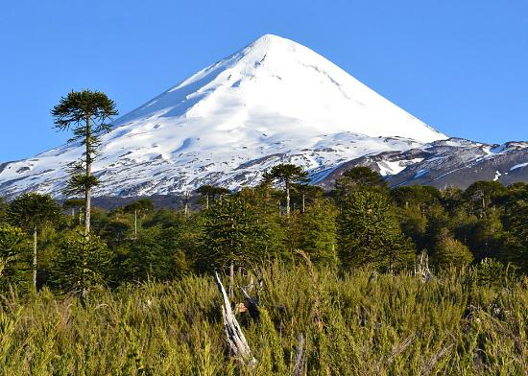
_____________________________________

Central Valley
Atamaca Desert
Easter Island
The Coastal Range
Chiloé Archipelago
The Andes
Villarrica volcano
Llaima volcano
Ojos del Salado volcano

