Year 3 Homework – W/C 13.5.24
Focus | Activity | Due | Completed
Reading | You should be reading at least 4x per week at home.  Please remember to record all reading in your reading diaries, including reading you do in school! You can write it in read and ask your adult to sign each one. | 17/5
Spelling  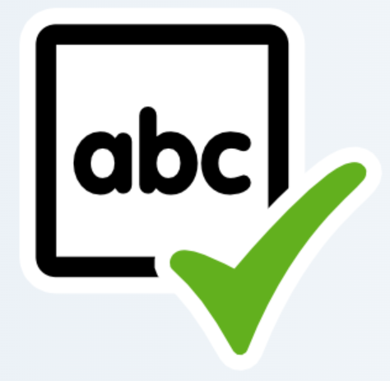 | This week's words:  missed, mist, plane, plain, scene, seen, rein, rain, blue, blew  When we test these, we’ll make sure to give a definition or put the word into a sentence.  Suggestions to help you learn these are:  - Write each spelling out 4 times  - Get an adult/older sibling to test you  - Spend 5/10 minutes each day practising them – little and often works best! | 17/5
Times tables  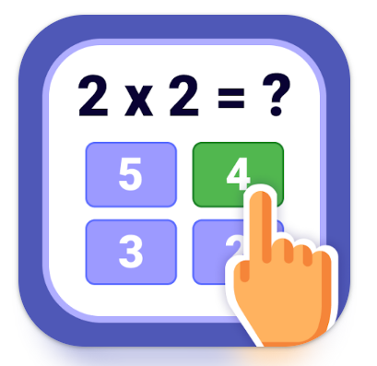 | Please practise the 5 times tables.  Extension: Have a go at a times table game online such as times table rock stars (we have a current tournament happening), Hit the Button or Marlon’s Magical Maths. We currently have a TTRS tournament up ! | 17/5
Other  Maths | A)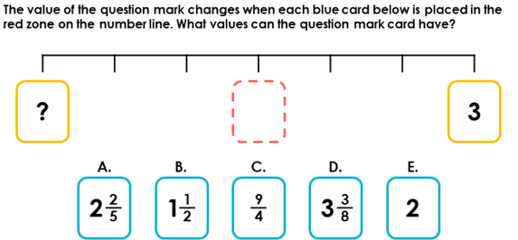  B) 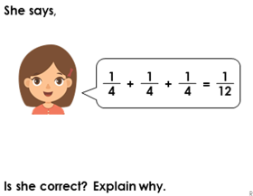 | 17/5

