Year 3 Homework – W/C 20.5.24
Focus | Activity | Due | Completed
Reading | You should be reading at least 4x per week at home.  Please remember to record all reading in your reading diaries, including reading you do in school! You can write it in read and ask your adult to sign each one. | 24/5
Spelling | This week, the children are to learn some words they’ve looked at previously. It might be tricky, as they wont all follow the same spelling pattern.  This week's words:  happy, happily, February, occasion, mist. plane, gentle, gently, complete, humbly, enclosure, extension, comprehension  Suggestions to help you learn these are:  - Write each spelling out 4 times  - Get an adult/older sibling to test you  - Spend 5/10 minutes each day practising them – little and often works best! | 24/5
Times tables  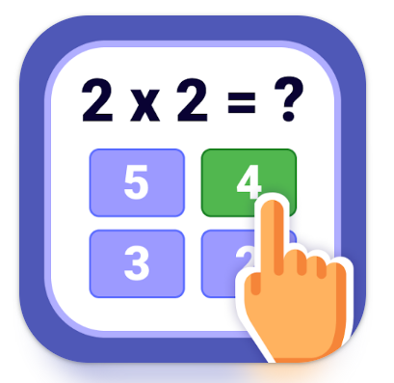 | Please practise the 12 times tables.  Extension: Have a go at a times table game online such as times table rock stars (we have a current tournament happening), Hit the Button or Marlon’s Magical Maths. We currently have a TTRS tournament up ! | 24/5
Other  Maths | - 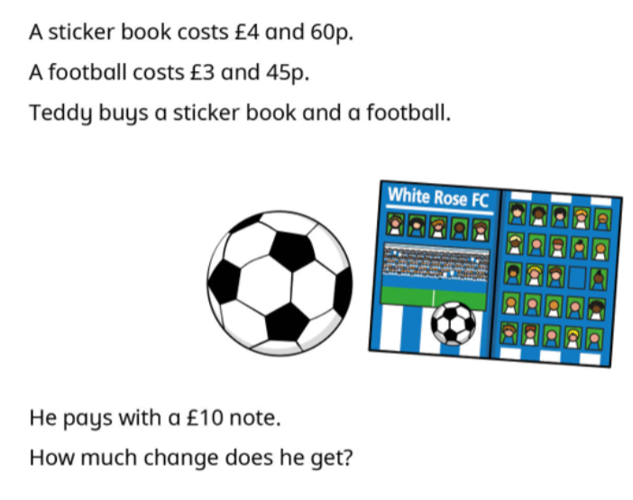  - 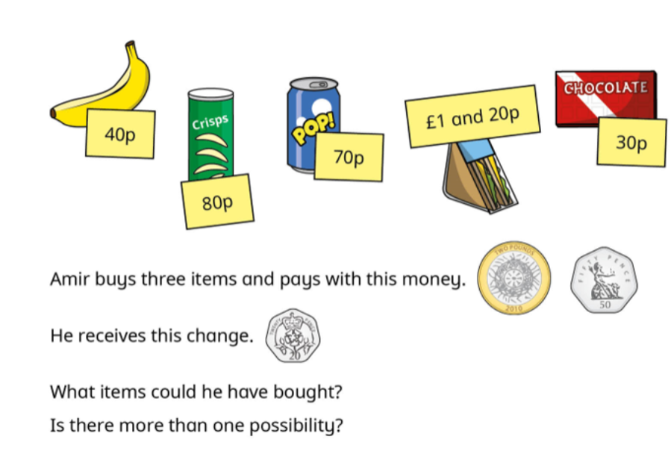 | 24/5

