Year 3 Homework – W/C 27.5.24
Focus | Activity | Due | Completed
Reading | You should be reading at least 4x per week at home.  Please remember to record all reading in your reading diaries, including reading you do in school! You can write it in read and ask your adult to sign each one. | 3/6
Spelling | Below are some words that we have noticed some children struuggled to spell. They’re common words, and it would be greatly beneficial if they managed to consistent write them correct.  The words:  there, they’re, their, decide, said, went, want, Wednesday, February, believe, thought, think, although  Suggestions to help you learn these are:  - Write each spelling out 4 times  - Get an adult/older sibling to test you  - Spend 5/10 minutes each day practising them – little and often works best! | 3/6
Times tables  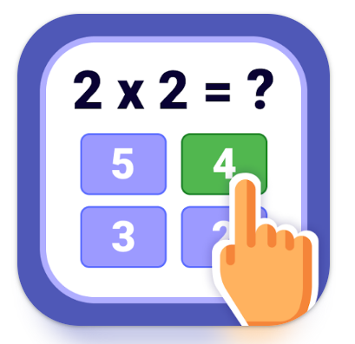 | Please practise the 6 times tables.  Extension: Have a go at a times table game online such as times table rock stars (we have a current tournament happening), Hit the Button or Marlon’s Magical Maths. We currently have a TTRS tournament up ! | 3/6
Other  DT | Next half term, we will be creating our own Teddy T-shirts. Using recycled fabric, we will be upcycling and creating new from old! The children will be using old t-shirts/cloth/cotton sheets, to create a new snazzy t-shirt for their cuddly friend.  Please bring the following, if possible:  - Teddy bear/soft toy - no more than 12inches – not their best/favourite teddy in case of mishap  - Cotton fabric – oversized t-shirt/fat quarter/cotton sheets/jean fabric  - Any extras they’d like to add to their design  If you have any extra fabric you’d be willing to part with, please donate to our DT in case some cannot supply their own.  