Year 3 Homework – W/C 5.2.24
Focus | Activity | Due | Completed
Reading | You should be reading at least 4 x per week at home.  Please remember to record all reading in your reading diaries, including reading you do in school! You can write it in read and ask your adult to sign each one. | 8/2
Spelling  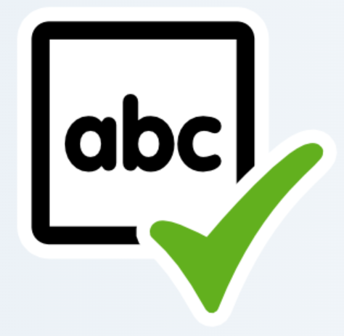 | You will be given spellings every week. We will be practising them in school and then testing at the end of each week.  words beginning with /n/ spelled <kn> and <gn>  knee, gnaw, knot, knock, gnash, knife, knight, gnarled, knuckle, knowledge  - gnocchi, knickknack  Suggestions to help you learn these are:  - Write each spelling out 4 times  - Get an adult/older sibling to test you  - Spend 5/10 minutes each day practising them – little and often works best! | 8/2
Times tables  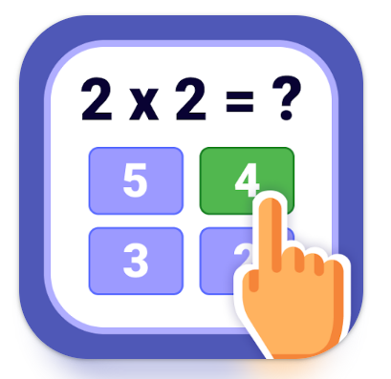 | Please practise the 5 times tables.  Extension: Have a go at a times table game online such as times table rock stars, Hit the Button or Marlon’s Magical Maths.  You should have now received your TTRS logins. Please let your class teacher know if you do not. | 8/2
Other | 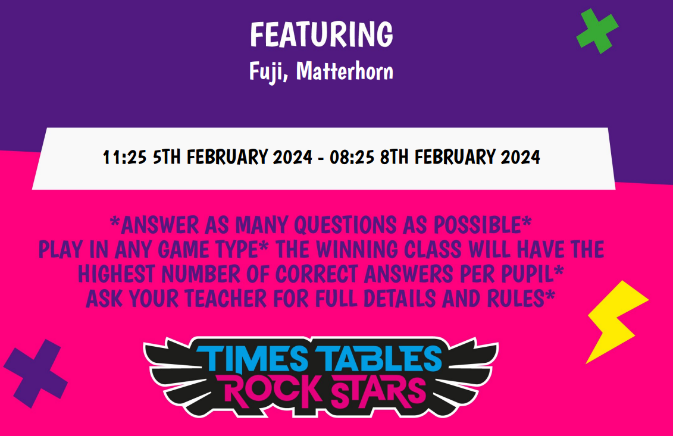 | 8/2

Year 3 Homework – W/C 5.2.24
Focus | Activity | Due | Completed
Reading | You should be reading at least 4 x per week at home.  Please remember to record all reading in your reading diaries, including reading you do in school! You can write it in read and ask your adult to sign each one. | 8/2
Spelling | You will be given spellings every week. We will be practising them in school and then testing at the end of each week.  words beginning with /n/ spelled <kn> and <gn>  knee, gnaw, knot, knock, gnash, knife, knight, gnarled, knuckle, knowledge  - gnocchi, knickknack  Suggestions to help you learn these are:  - Write each spelling out 4 times  - Get an adult/older sibling to test you  - Spend 5/10 minutes each day practising them – little and often works best! | 8/2
Times tables | Please practise the 5 times tables.  Extension: Have a go at a times table game online such as times table rock stars, Hit the Button or Marlon’s Magical Maths.  You should have now received your TTRS logins. Please let your class teacher know if you do not. | 8/2
Other |  | 8/2

