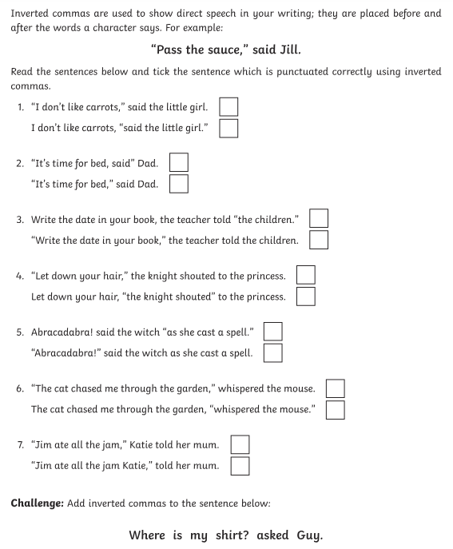

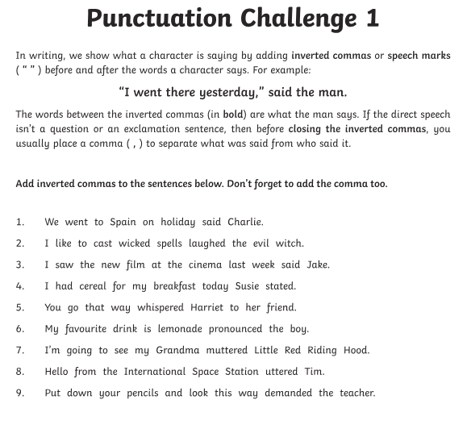

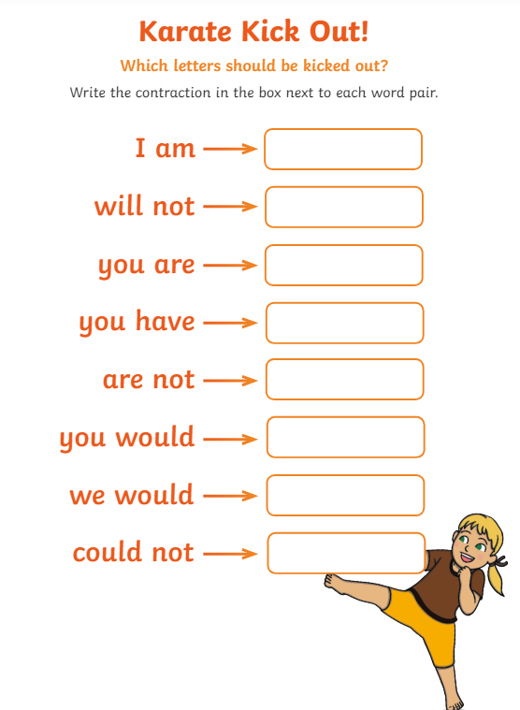

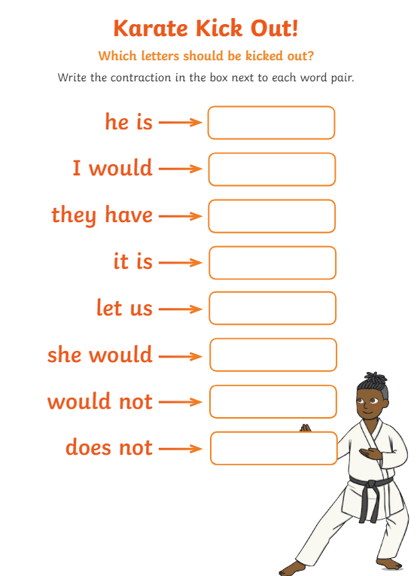

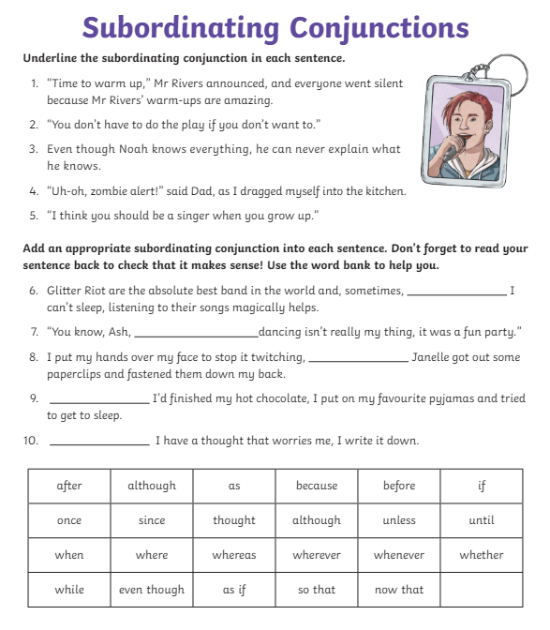

Once you have completed the Inverted commas, contraction and the subordinating conjunction worksheets write a story about a trek (walk) up a mountain using the grammar activities.
Think about the work we have previously covered in class about Mount Marapi be as creative and imaginative as possible.

