Religious Education
Sanatana Dharma
Today you are going to continue to learn about the Puja tray.
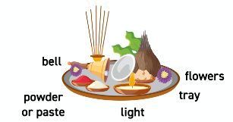

- A Sanatani might ring a bell to begin the act of praying
- Then they might light some incense
- They might also wash the statue of the deity (known as the murti)
- Their offering to the deity might be fruit or flowers. If it is food, it will be shared after the prayer to receive a blessing from the deity

- They might have a special lamp which is lit. They will often move this around the murti in a circle which symbolises the love of the deities
- They may sing hymns (bhajans) or mantras (phrases which are repeated)
- Then the worshipper might mark their forehead with powder or paste, and also place some on the murti as a blessing
Because all Sanatanis are individual, they may have slightly different items on their trays.

What senses are the Sanatanis using in their prayer?
When we do something which uses all our senses, do we tend to think about it more deeply or remember its meaning more?
How does praying or thinking about the qualities of a particular deity help a Sanatani lead a good life?

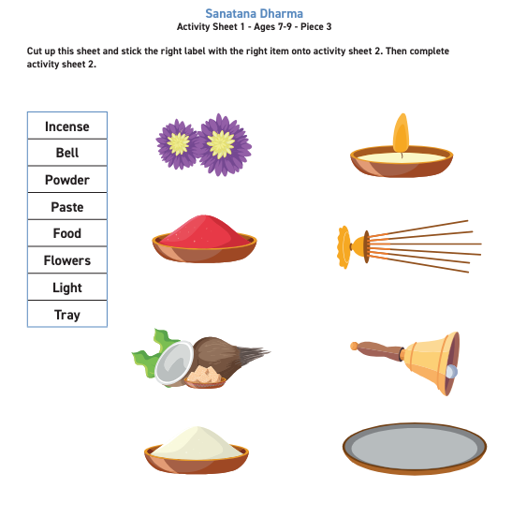
Independent:

Challenge:
Create an example of a Puja tray from every day items you can find at home. Once you have completed your tray take a picture and attach it to your work.
Or
Draw a diagram and label what your Puja tray was made from.

