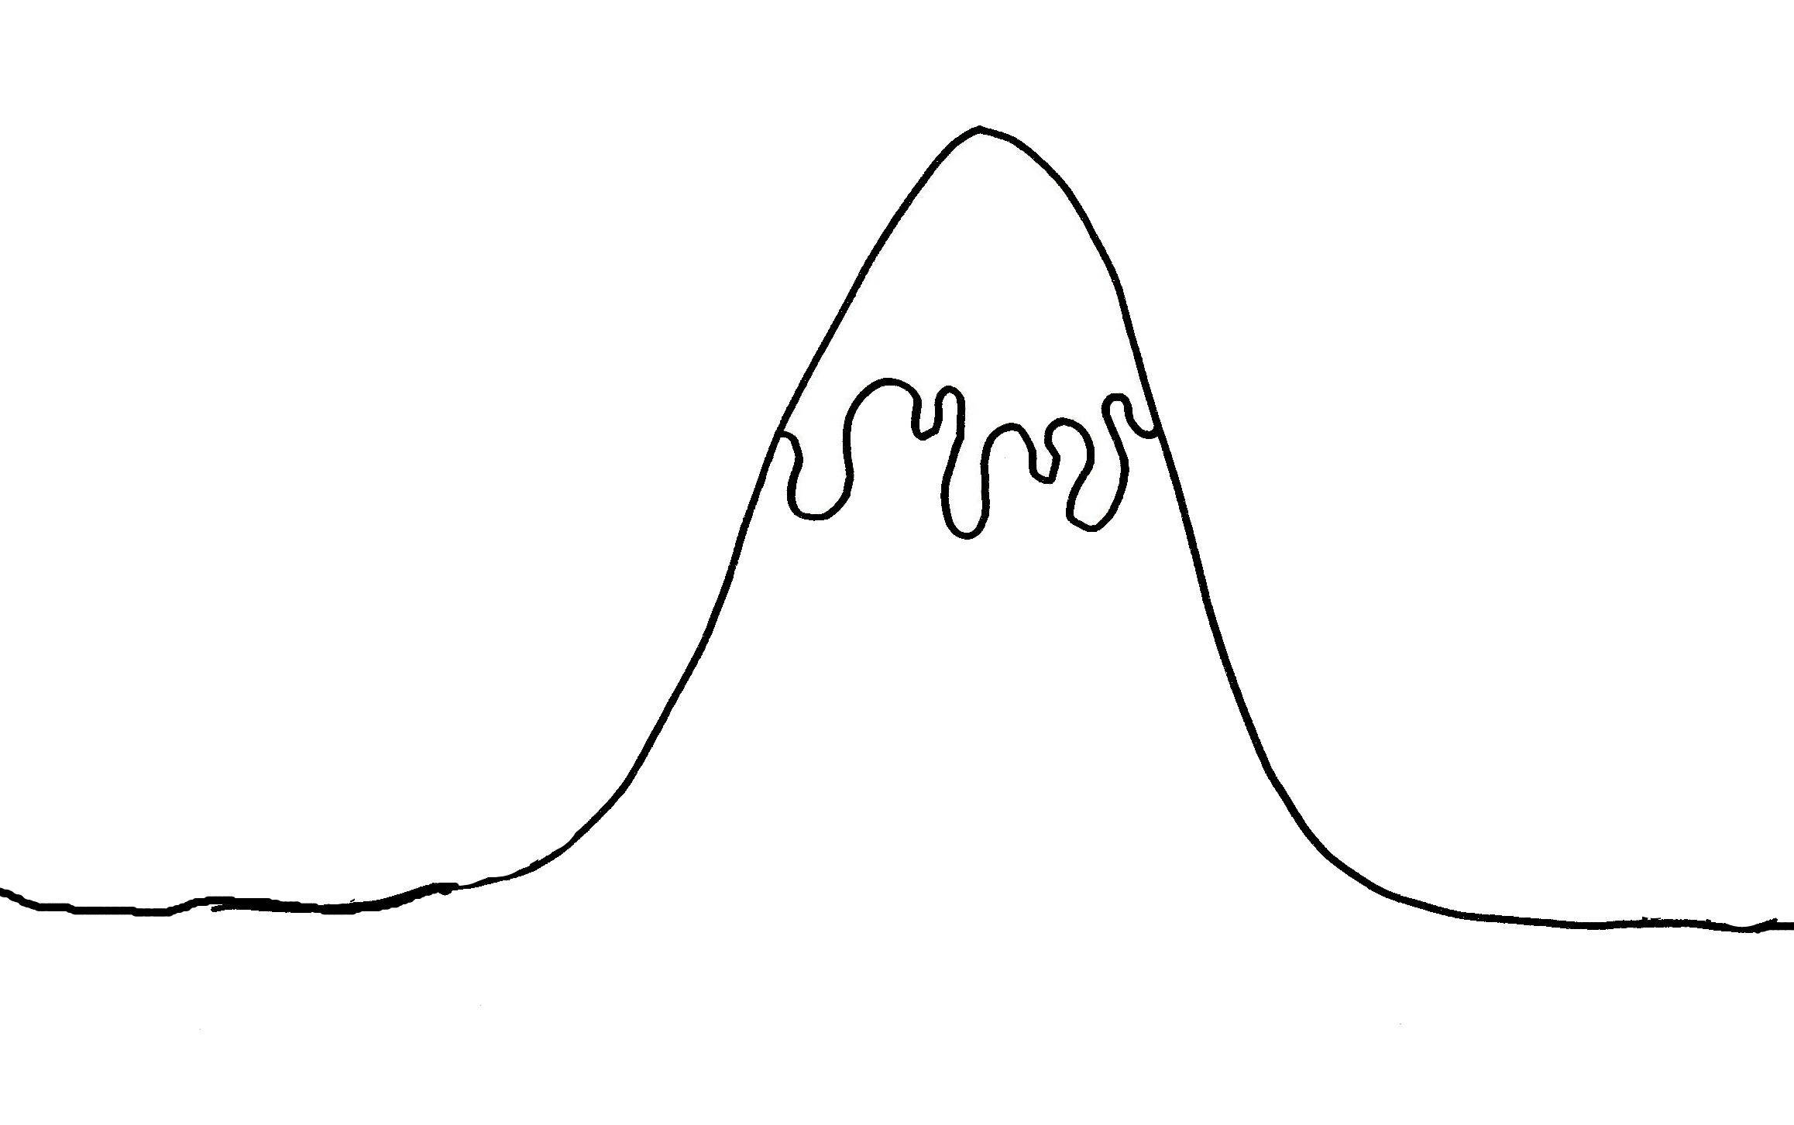

**Ending**

____________________________________________________________

**Fix problem**

______________________________________________________________________________________________________

**Problem!!**

_______________________________________________________________

**Introduction**

Who:____________________Where:___________________________________________________-

**Build up**

____________________________________________________________________________________________________________________________________________

**The Story Mountain**

**Ending**

____________________________________________________________

**Fix problem**

______________________________________________________________________________________________________

**Problem!!**

_______________________________________________________________

**Introduction**

Who:____________________Where:___________________________________________________-

**Build up**

____________________________________________________________________________________________________________________________________________

**The Story Mountain**